**Restaurant**

**Tobin Saji Antony**

**CODE:**

**restaurant.html**

<!DOCTYPE html>

<html lang="en">

<head>

  <title>Bootstrap Example</title>

  <meta charset="utf-8">

  <meta name="viewport" content="width=device-width, initial-scale=1">

  <link rel="stylesheet" href="https://stackpath.bootstrapcdn.com/bootstrap/4.3.1/css/bootstrap.min.css" integrity="sha384-ggOyR0iXCbMQv3Xipma34MD+dH/1fQ784/j6cY/iJTQUOhcWr7x9JvoRxT2MZw1T" crossorigin="anonymous">

    <!-- Optional JavaScript -->

    <!-- jQuery first, then Popper.js, then Bootstrap JS -->

    <script src="https://code.jquery.com/jquery-3.3.1.slim.min.js" integrity="sha384-q8i/X+965DzO0rT7abK41JStQIAqVgRVzpbzo5smXKp4YfRvH+8abtTE1Pi6jizo" crossorigin="anonymous"></script>

    <script src="https://cdnjs.cloudflare.com/ajax/libs/popper.js/1.14.7/umd/popper.min.js" integrity="sha384-UO2eT0CpHqdSJQ6hJty5KVphtPhzWj9WO1clHTMGa3JDZwrnQq4sF86dIHNDz0W1" crossorigin="anonymous"></script>

    <script src="https://stackpath.bootstrapcdn.com/bootstrap/4.3.1/js/bootstrap.min.js" integrity="sha384-JjSmVgyd0p3pXB1rRibZUAYoIIy6OrQ6VrjIEaFf/nJGzIxFDsf4x0xIM+B07jRM" crossorigin="anonymous"></script>

<style>

  .carousel-inner{

  width:100%;

  max-height: 600px !important;

}

  .btn-margin{

    margin-top: 10px;

    margin-bottom: 10px;

  }

</style>

  </head>

<body>

<!-- Navbar -->

<nav class="navbar navbar-expand-lg navbar-light bg-light">

    <a class="navbar-brand" href="restaurant.html">Ming’s Diner</a>

    <button class="navbar-toggler" type="button" data-toggle="collapse" data-target="#navbarNav" aria-controls="navbarNav" aria-expanded="false" aria-label="Toggle navigation">

      <span class="navbar-toggler-icon"></span>

    </button>

    <div class="collapse navbar-collapse" id="navbarNav">

      <ul class="navbar-nav">

        <li class="nav-item">

          <a class="nav-link" href="order.html">Orders</a>

        </li>

        <li class="nav-item">

          <a class="nav-link" href="contactus.html">Contact Us</a>

        </li>

      </ul>

    </div>

  </nav>

<!--navbar end  -->

<div class="container-fluid">

<!-- carousal -->

<div class="row">

    <div class="col">

<div id="carouselExampleIndicators" class="carousel slide" data-ride="carousel">

    <ol class="carousel-indicators">

      <li data-target="#carouselExampleIndicators" data-slide-to="0" class="active"></li>

      <li data-target="#carouselExampleIndicators" data-slide-to="1"></li>

      <li data-target="#carouselExampleIndicators" data-slide-to="2"></li>

    </ol>

    <div class="carousel-inner">

      <div class="carousel-item active">

        <img class="d-block w-100" src="images/2.jpg" alt="First slide">

      </div>

      <div class="carousel-item">

        <img class="d-block w-100" src="images/3.jpg" alt="Second slide">

      </div>

      <div class="carousel-item">

        <img class="d-block w-100" src="images/10.jpg" alt="Third slide">

      </div>

    </div>

    <a class="carousel-control-prev" href="#carouselExampleIndicators" role="button" data-slide="prev">

      <span class="carousel-control-prev-icon" aria-hidden="true"></span>

      <span class="sr-only">Previous</span>

    </a>

    <a class="carousel-control-next" href="#carouselExampleIndicators" role="button" data-slide="next">

      <span class="carousel-control-next-icon" aria-hidden="true"></span>

      <span class="sr-only">Next</span>

    </a>

  </div>

    </div>

</div>

<!-- carousal end -->

<div class="row">

  <div class="col">

    <a href="order.html" class="btn btn-primary btn-lg btn-margin">Order Now</a>

  </div>

</div>

<!-- card begin -->

<h2>Best Sellers</h2>

<div class="row">

    <div class="col-md-3">

<div class="card shadow p-3 mb-5 bg-white rounded" style="width: 18rem;">

    <img class="card-img-top" src="images/4.jpg" alt="Card image cap">

    <div class="card-body">

      <p class="card-text">Some quick example text to build on the card title and make up the bulk of the card's content.</p>

    </div>

  </div>

    </div>

    <div class="col-md-3">

        <div class="card shadow p-3 mb-5 bg-white rounded" style="width: 18rem;">

            <img class="card-img-top" src="images/5.jpg" alt="Card image cap">

            <div class="card-body">

              <p class="card-text">Some quick example text to build on the card title and make up the bulk of the card's content.</p>

            </div>

          </div>

            </div>

            <div class="col-md-3">

                <div class="card shadow p-3 mb-5 bg-white rounded" style="width: 18rem;">

                    <img class="card-img-top" src="images/1.jpg" alt="Card image cap">

                    <div class="card-body">

                      <p class="card-text">Some quick example text to build on the card title and make up the bulk of the card's content.</p>

                    </div>

                  </div>

                    </div>

                    <div class="col-md-3">

                      <div class="card shadow p-3 mb-5 bg-white rounded" style="width: 18rem;">

                          <img class="card-img-top" src="images/10.jpg" alt="Card image cap">

                          <div class="card-body">

                            <p class="card-text">Some quick example text to build on the card title and make up the bulk of the card's content.</p>

                          </div>

                        </div>

                          </div>

</div>

<div class="row">

    <div class="col-md-3">

<div class="card shadow p-3 mb-5 bg-white rounded" style="width: 18rem;">

    <img class="card-img-top" src="images/6.jpg" alt="Card image cap">

    <div class="card-body">

      <p class="card-text">Some quick example text to build on the card title and make up the bulk of the card's content.</p>

    </div>

  </div>

    </div>

    <div class="col-md-3">

        <div class="card shadow p-3 mb-5 bg-white rounded" style="width: 18rem;">

            <img class="card-img-top" src="images/2.jpg" alt="Card image cap">

            <div class="card-body">

              <p class="card-text">Some quick example text to build on the card title and make up the bulk of the card's content.</p>

            </div>

          </div>

            </div>

            <div class="col-md-3">

                <div class="card shadow p-3 mb-5 bg-white rounded" style="width: 18rem;">

                    <img class="card-img-top" src="images/3.jpg" alt="Card image cap">

                    <div class="card-body">

                      <p class="card-text">Some quick example text to build on the card title and make up the bulk of the card's content.</p>

                    </div>

                  </div>

                    </div>

                    <div class="col-md-3">

                      <div class="card shadow p-3 mb-5 bg-white rounded" style="width: 18rem;">

                          <img class="card-img-top" src="images/8.jpg" alt="Card image cap">

                          <div class="card-body">

                            <p class="card-text">Some quick example text to build on the card title and make up the bulk of the card's content.</p>

                          </div>

                        </div>

                          </div>

</div>

<!-- card end -->

</div>

</body>

</html>

**Order.html**

<!DOCTYPE html>

<html lang="en">

<head>

  <title>Bootstrap Example</title>

  <meta charset="utf-8">

  <meta name="viewport" content="width=device-width, initial-scale=1">

  <link rel="stylesheet" href="https://stackpath.bootstrapcdn.com/bootstrap/4.3.1/css/bootstrap.min.css" integrity="sha384-ggOyR0iXCbMQv3Xipma34MD+dH/1fQ784/j6cY/iJTQUOhcWr7x9JvoRxT2MZw1T" crossorigin="anonymous">

    <!-- Optional JavaScript -->

    <!-- jQuery first, then Popper.js, then Bootstrap JS -->

    <script src="https://code.jquery.com/jquery-3.3.1.slim.min.js" integrity="sha384-q8i/X+965DzO0rT7abK41JStQIAqVgRVzpbzo5smXKp4YfRvH+8abtTE1Pi6jizo" crossorigin="anonymous"></script>

    <script src="https://cdnjs.cloudflare.com/ajax/libs/popper.js/1.14.7/umd/popper.min.js" integrity="sha384-UO2eT0CpHqdSJQ6hJty5KVphtPhzWj9WO1clHTMGa3JDZwrnQq4sF86dIHNDz0W1" crossorigin="anonymous"></script>

    <script src="https://stackpath.bootstrapcdn.com/bootstrap/4.3.1/js/bootstrap.min.js" integrity="sha384-JjSmVgyd0p3pXB1rRibZUAYoIIy6OrQ6VrjIEaFf/nJGzIxFDsf4x0xIM+B07jRM" crossorigin="anonymous"></script>

  <style>

       .btn-margin{

    margin-top: 20px;

    margin-bottom: 10px;

  }

  </style>

  <script>

function myFunction() {

    alert('Item added successfully!')

}

  </script>

</head>

<body>

    <!-- Navbar -->

<nav class="navbar navbar-expand-lg navbar-light bg-light">

    <a class="navbar-brand" href="restaurant.html">Ming’s Diner</a>

    <button class="navbar-toggler" type="button" data-toggle="collapse" data-target="#navbarNav" aria-controls="navbarNav" aria-expanded="false" aria-label="Toggle navigation">

      <span class="navbar-toggler-icon"></span>

    </button>

    <div class="collapse navbar-collapse" id="navbarNav">

      <ul class="navbar-nav">

        <li class="nav-item active">

          <a class="nav-link" href="order.html">Orders</a>

        </li>

        <li class="nav-item">

          <a class="nav-link" href="contactus.html">Contact Us</a>

        </li>

      </ul>

    </div>

  </nav>

<!--navbar end  -->

    <div class="container-fluid">

        <h2>Items</h2>

       <!-- card begin -->

<div class="row btn-margin">

    <div class="col-md-3">

<div class="card shadow p-3 mb-5 bg-white rounded" style="width: 18rem;">

    <img class="card-img-top" src="images/4.jpg" alt="Card image cap">

    <div class="card-body">

      <p class="card-text">Some quick example text to build on the card title and make up the bulk of the card's content.</p>

      <button class="btn btn-primary" onclick="myFunction()">Add To Cart</button>

    </div>

  </div>

    </div>

    <div class="col-md-3">

        <div class="card shadow p-3 mb-5 bg-white rounded" style="width: 18rem;">

            <img class="card-img-top" src="images/5.jpg" alt="Card image cap">

            <div class="card-body">

              <p class="card-text">Some quick example text to build on the card title and make up the bulk of the card's content.</p>

              <button class="btn btn-primary" onclick="myFunction()">Add To Cart</button>

            </div>

          </div>

            </div>

            <div class="col-md-3">

                <div class="card shadow p-3 mb-5 bg-white rounded" style="width: 18rem;">

                    <img class="card-img-top" src="images/1.jpg" alt="Card image cap">

                    <div class="card-body">

                      <p class="card-text">Some quick example text to build on the card title and make up the bulk of the card's content.</p>

                      <button class="btn btn-primary" onclick="myFunction()">Add To Cart</button>

                    </div>

                  </div>

                    </div>

                    <div class="col-md-3">

                      <div class="card shadow p-3 mb-5 bg-white rounded" style="width: 18rem;">

                          <img class="card-img-top" src="images/10.jpg" alt="Card image cap">

                          <div class="card-body">

                            <p class="card-text">Some quick example text to build on the card title and make up the bulk of the card's content.</p>

                            <button class="btn btn-primary" onclick="myFunction()">Add To Cart</button>

                        </div>

                        </div>

                          </div>

</div>

<div class="row">

    <div class="col-md-3">

<div class="card shadow p-3 mb-5 bg-white rounded" style="width: 18rem;">

    <img class="card-img-top" src="images/6.jpg" alt="Card image cap">

    <div class="card-body">

        <p class="card-text">Some quick example text to build on the card title and make up the bulk of the card's content.</p>

        <button class="btn btn-primary" onclick="myFunction()">Add To Cart</button>

    </div>

  </div>

    </div>

    <div class="col-md-3">

        <div class="card shadow p-3 mb-5 bg-white rounded" style="width: 18rem;">

            <img class="card-img-top" src="images/2.jpg" alt="Card image cap">

            <div class="card-body">

                <p class="card-text">Some quick example text to build on the card title and make up the bulk of the card's content.</p>

                <button class="btn btn-primary" onclick="myFunction()">Add To Cart</button>

            </div>

          </div>

            </div>

            <div class="col-md-3">

                <div class="card shadow p-3 mb-5 bg-white rounded" style="width: 18rem;">

                    <img class="card-img-top" src="images/3.jpg" alt="Card image cap">

                    <div class="card-body">

                      <p class="card-text">Some quick example text to build on the card title and make up the bulk of the card's content.</p>

                      <button class="btn btn-primary" onclick="myFunction()">Add To Cart</button>

                    </div>

                  </div>

                    </div>

                    <div class="col-md-3">

                      <div class="card shadow p-3 mb-5 bg-white rounded" style="width: 18rem;">

                          <img class="card-img-top" src="images/8.jpg" alt="Card image cap">

                          <div class="card-body">

                            <p class="card-text">Some quick example text to build on the card title and make up the bulk of the card's content.</p>

                            <button class="btn btn-primary" onclick="myFunction()">Add To Cart</button>

                        </div>

                        </div>

                          </div>

</div>

<!-- card end -->

</div>

</body>

</html>

**Contactus.html**

<!DOCTYPE html>

<html lang="en">

<head>

  <title>Bootstrap Example</title>

  <meta charset="utf-8">

  <meta name="viewport" content="width=device-width, initial-scale=1">

  <link rel="stylesheet" href="https://stackpath.bootstrapcdn.com/bootstrap/4.3.1/css/bootstrap.min.css" integrity="sha384-ggOyR0iXCbMQv3Xipma34MD+dH/1fQ784/j6cY/iJTQUOhcWr7x9JvoRxT2MZw1T" crossorigin="anonymous">

    <!-- Optional JavaScript -->

    <!-- jQuery first, then Popper.js, then Bootstrap JS -->

    <script src="https://code.jquery.com/jquery-3.3.1.slim.min.js" integrity="sha384-q8i/X+965DzO0rT7abK41JStQIAqVgRVzpbzo5smXKp4YfRvH+8abtTE1Pi6jizo" crossorigin="anonymous"></script>

    <script src="https://cdnjs.cloudflare.com/ajax/libs/popper.js/1.14.7/umd/popper.min.js" integrity="sha384-UO2eT0CpHqdSJQ6hJty5KVphtPhzWj9WO1clHTMGa3JDZwrnQq4sF86dIHNDz0W1" crossorigin="anonymous"></script>

    <script src="https://stackpath.bootstrapcdn.com/bootstrap/4.3.1/js/bootstrap.min.js" integrity="sha384-JjSmVgyd0p3pXB1rRibZUAYoIIy6OrQ6VrjIEaFf/nJGzIxFDsf4x0xIM+B07jRM" crossorigin="anonymous"></script>

  <style>

       .btn-margin{

    margin-top: 20px;

    margin-bottom: 10px;

  }

  </style>

  <script>

function myFunction() {

    alert('Item added successfully!')

}

  </script>

</head>

<body>

    <!-- Navbar -->

<nav class="navbar navbar-expand-lg navbar-light bg-light">

    <a class="navbar-brand" href="restaurant.html">Ming’s Diner</a>

    <button class="navbar-toggler" type="button" data-toggle="collapse" data-target="#navbarNav" aria-controls="navbarNav" aria-expanded="false" aria-label="Toggle navigation">

      <span class="navbar-toggler-icon"></span>

    </button>

    <div class="collapse navbar-collapse" id="navbarNav">

      <ul class="navbar-nav">

        <li class="nav-item active">

          <a class="nav-link" href="order.html">Orders</a>

        </li>

        <li class="nav-item">

          <a class="nav-link" href="contactus.html">Contact Us</a>

        </li>

      </ul>

    </div>

  </nav>

<!--navbar end  -->

    <div class="container-fluid">

        <h2>Items</h2>

       <!-- card begin -->

<div class="row btn-margin">

    <div class="col-md-3">

<div class="card shadow p-3 mb-5 bg-white rounded" style="width: 18rem;">

    <img class="card-img-top" src="images/4.jpg" alt="Card image cap">

    <div class="card-body">

      <p class="card-text">Some quick example text to build on the card title and make up the bulk of the card's content.</p>

      <button class="btn btn-primary" onclick="myFunction()">Add To Cart</button>

    </div>

  </div>

    </div>

    <div class="col-md-3">

        <div class="card shadow p-3 mb-5 bg-white rounded" style="width: 18rem;">

            <img class="card-img-top" src="images/5.jpg" alt="Card image cap">

            <div class="card-body">

              <p class="card-text">Some quick example text to build on the card title and make up the bulk of the card's content.</p>

              <button class="btn btn-primary" onclick="myFunction()">Add To Cart</button>

            </div>

          </div>

            </div>

            <div class="col-md-3">

                <div class="card shadow p-3 mb-5 bg-white rounded" style="width: 18rem;">

                    <img class="card-img-top" src="images/1.jpg" alt="Card image cap">

                    <div class="card-body">

                      <p class="card-text">Some quick example text to build on the card title and make up the bulk of the card's content.</p>

                      <button class="btn btn-primary" onclick="myFunction()">Add To Cart</button>

                    </div>

                  </div>

                    </div>

                    <div class="col-md-3">

                      <div class="card shadow p-3 mb-5 bg-white rounded" style="width: 18rem;">

                          <img class="card-img-top" src="images/10.jpg" alt="Card image cap">

                          <div class="card-body">

                            <p class="card-text">Some quick example text to build on the card title and make up the bulk of the card's content.</p>

                            <button class="btn btn-primary" onclick="myFunction()">Add To Cart</button>

                        </div>

                        </div>

                          </div>

</div>

<div class="row">

    <div class="col-md-3">

<div class="card shadow p-3 mb-5 bg-white rounded" style="width: 18rem;">

    <img class="card-img-top" src="images/6.jpg" alt="Card image cap">

    <div class="card-body">

        <p class="card-text">Some quick example text to build on the card title and make up the bulk of the card's content.</p>

        <button class="btn btn-primary" onclick="myFunction()">Add To Cart</button>

    </div>

  </div>

    </div>

    <div class="col-md-3">

        <div class="card shadow p-3 mb-5 bg-white rounded" style="width: 18rem;">

            <img class="card-img-top" src="images/2.jpg" alt="Card image cap">

            <div class="card-body">

                <p class="card-text">Some quick example text to build on the card title and make up the bulk of the card's content.</p>

                <button class="btn btn-primary" onclick="myFunction()">Add To Cart</button>

            </div>

          </div>

            </div>

            <div class="col-md-3">

                <div class="card shadow p-3 mb-5 bg-white rounded" style="width: 18rem;">

                    <img class="card-img-top" src="images/3.jpg" alt="Card image cap">

                    <div class="card-body">

                      <p class="card-text">Some quick example text to build on the card title and make up the bulk of the card's content.</p>

                      <button class="btn btn-primary" onclick="myFunction()">Add To Cart</button>

                    </div>

                  </div>

                    </div>

                    <div class="col-md-3">

                      <div class="card shadow p-3 mb-5 bg-white rounded" style="width: 18rem;">

                          <img class="card-img-top" src="images/8.jpg" alt="Card image cap">

                          <div class="card-body">

                            <p class="card-text">Some quick example text to build on the card title and make up the bulk of the card's content.</p>

                            <button class="btn btn-primary" onclick="myFunction()">Add To Cart</button>

                        </div>

                        </div>

                          </div>

</div>

<!-- card end -->

</div>

</body>

</html>

**SCREENSHOTS**

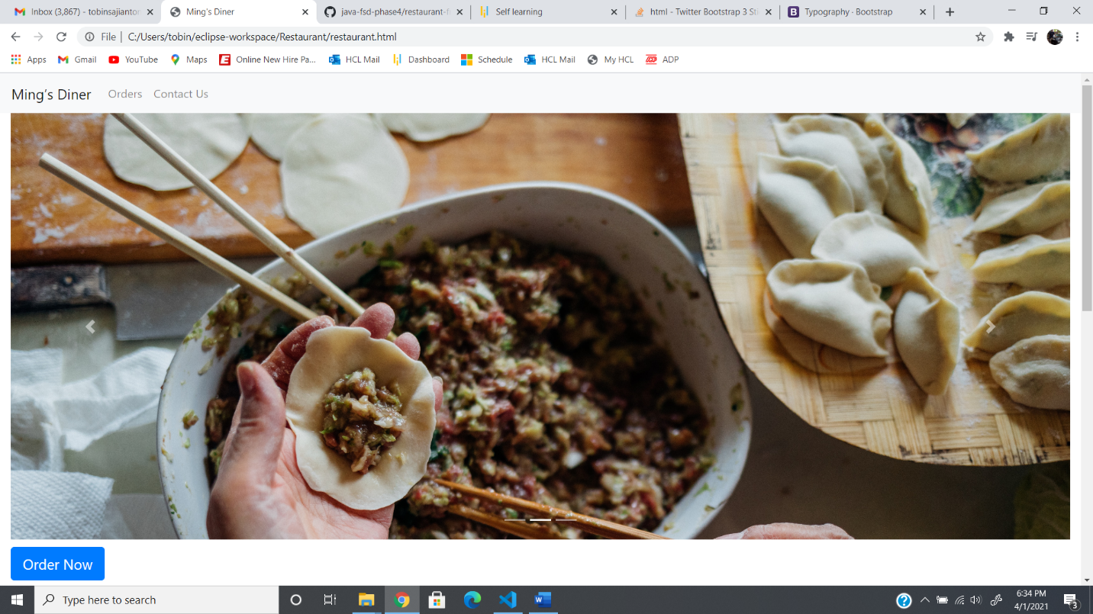

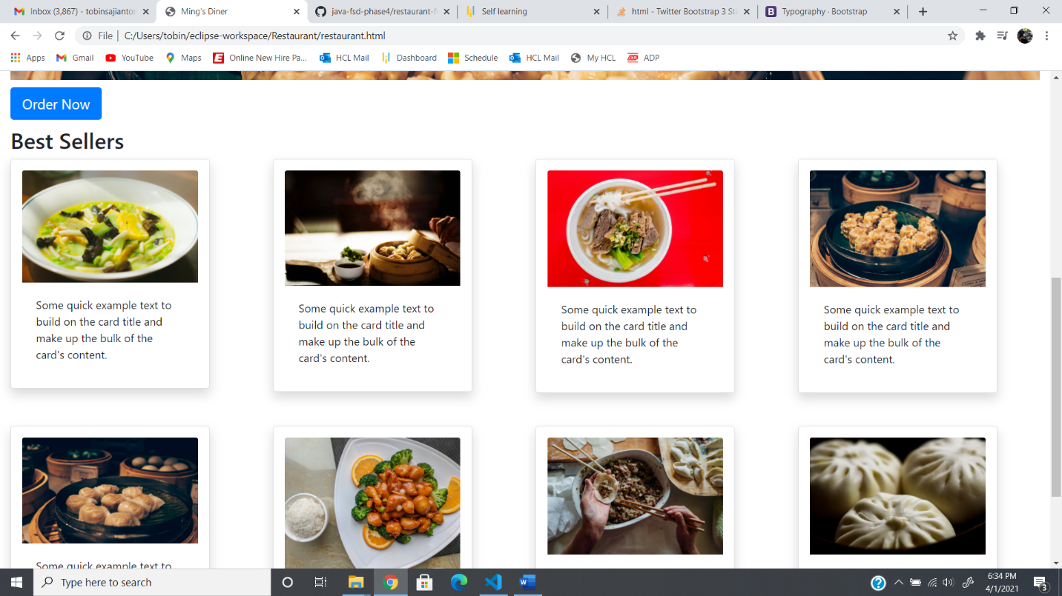

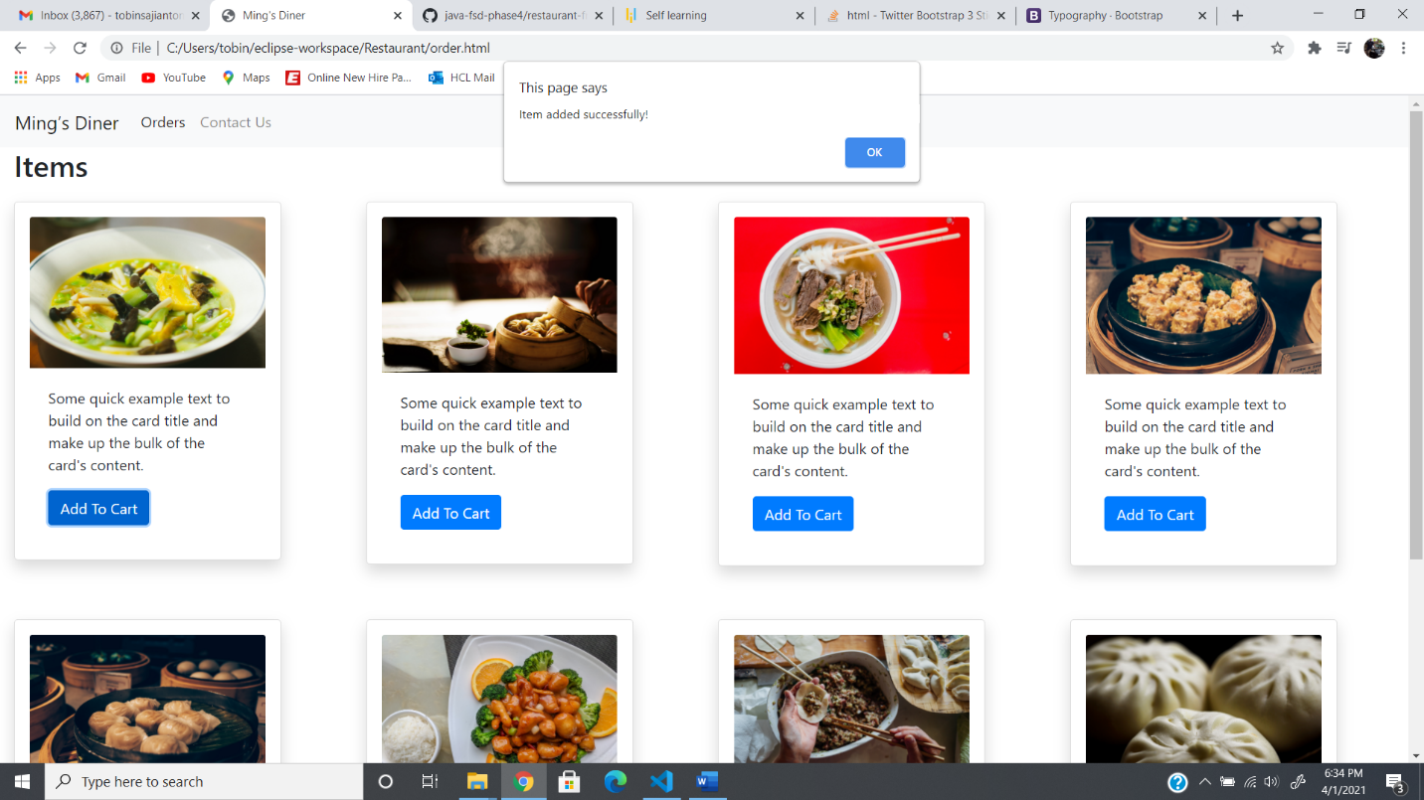

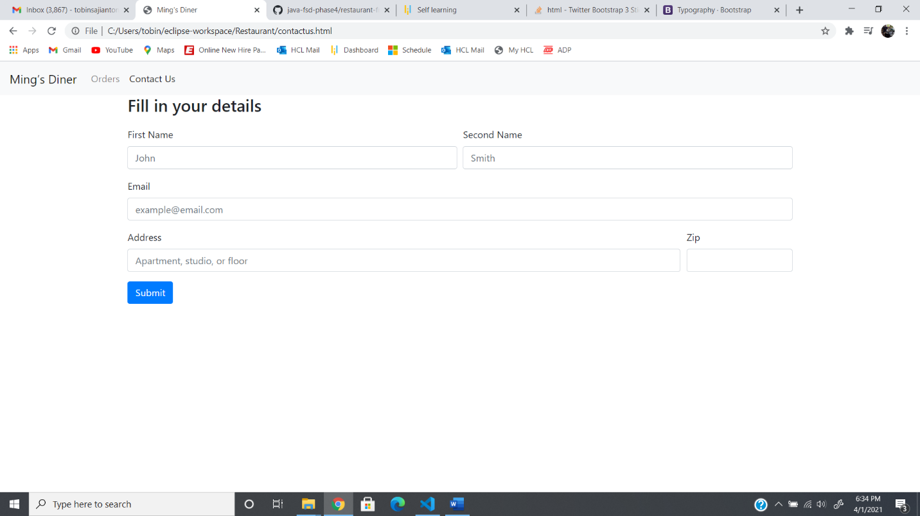

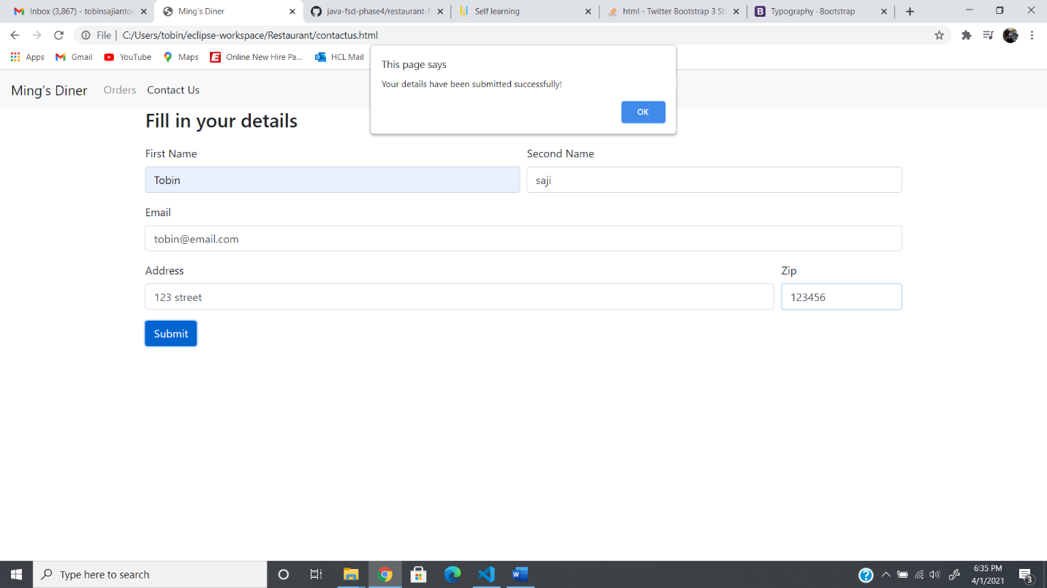

**GITHUB LINK:**

https://github.com/tobinsajiantony/Java_fsd_Phase_4_Restaurant